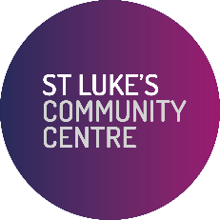

VOLUNTEER APPLICATION FORM

Please complete this form using BLOCK CAPITALS

Volunteer role being applied for (if known) __________________________________________________

Contact Details

Name __________________________________________________________________________________

Address__________________________________________________________________________________

______________________________________________________ Post Code _________________________­­

Tel _____________________________________

Date of Birth _____ / ______ / ________ (dd/mm/yyyy)

Email ________________________________________________________________________

What particularly interests you in volunteering at St Luke’s? (Tick all boxes that apply)

Personal and professional development Socialising

Work experience Other – please specify ________________________________

Personal Profile

Please use the space below to tell us additional information about yourself. This will help us find you the right volunteer role.

_______________________________________________________________________________________

_______________________________________________________________________________________

_______________________________________________________________________________________

_______________________________________________________________________________________

Availability (please tick box/s)

I can usually offer my time:

At one off events

Regularly – please tick all that apply Monday

Tuesday

Wednesday

Thursday

Friday

Saturday

Sunday

Other – please specify ____________________________________________________

Do you have any special requirements that we should be aware of? Eg. large print, wheelchair access, induction loop etc

_______________________________________________________________________________________

Emergency Contact Details /Next of Kin

Name __________________________________________________________________­_________________

Relationship to you _______________________________________________________________________

Phone Number ___________________________________________________________________________

Do you have the right to volunteer in the United Kingdom? Yes No

If you become a St Luke’s volunteer you will be asked to provide the relevant documents as evidence.

Do you have any criminal convictions, including “spent” convictions? Yes No

Depending on your volunteer role we may be required to carry out a Disclosure Barring Service check.

Declaration

I confirm that the information on this form is correct.

By submitting this form, you give permission for St Luke's to store your personal data until you tell us not to for purposes related to St Luke's. We will not pass this data onto any third party without permission, and if at any time you wish us to change your preferences or delete your details please write to: Executive Assistant, St Luke's Community Centre, 90 Central Street, London EC1V 8AJ or email privacy@slpt.org.uk. Please refer to our Privacy Statement on the website for further details, which we can email or post to you on request.

Signature ………................................................... Date …...... /…….... / ……………… (dd/mm/yyyy)

St Luke’s is committed to equality. For monitoring purposes, please also complete the attached Equal Opportunities form and return it to us with your completed application form (optional).

Please return your completed application form to:

Holly Willmott

Community Engagement & Volunteer Coordinator

St Luke’s Community Centre

90 Central Street

London EC1V 8AJ

Tel: 020 7549 8190

Email: [hwillmott@slpt.org.uk](mailto:hwillmott@slpt.org.uk)

Thank you for showing an interest in volunteering at St Luke’s Community Centre.

St Luke’s aims to improve the quality of life for the residents of south Islington by making the neighbourhood a better place to live, work, learn and play. We own a large multi-purpose community centre for the provision of community services and activities to all age groups, including an extensive programme of older people’s services and activities, a job club, gardening and food growing, volunteering, business and social enterprise support, a community café, corporate volunteering, after school and holiday activities.

Local residents interested in volunteering at St Luke’s are asked to complete and return the attached form. All candidates will be interviewed to assess their interest and suitability in current voluntary roles. Volunteers will be asked to provide contact details of one referee which must be received before a role begins.

St Luke’s has limited volunteering opportunities and gives priority to applicants who live or work in our charity’s ‘area of benefit’ in south Islington.

New volunteers will be provided with a Volunteer Handbook, a role outline and a volunteer agreement. Volunteers will have a named supervisor who will provide an induction and support throughout their time at St Luke’s.

We hope that all volunteers find their time at St Luke’s both satisfying and rewarding.

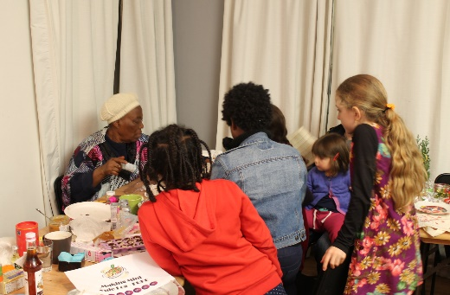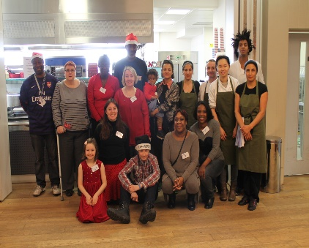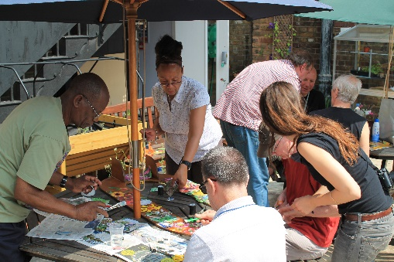



NEW VOLUNTEERS – EQUAL OPPORTUNITIES MONITORING FORM

(Optional)

St Luke’s promotes equal opportunities. It aims to ensure that all job applicants, volunteers and employees receive equal treatment regardless of age, disability, ethnic origin, gender, race, religion, responsibility for dependants or sexual orientation.

Please help us to monitor the effectiveness of our Equality Policy by filling out the form below and returning it with your completed volunteer application form.

Gender

Male Female Non-binary

Age

18-29 30-39 40-49 50-59 60-69 70+

Disability

Do you consider yourself to have a disability or mental impairment which has a substantial and long-term effect of your ability to carry out normal day-to-day activities?

Yes No

If “yes” please specify

……………………………………………………………………………………………………………………………………………………………………

Ethnic origin

White: Asian or Asian British:

British Indian

Irish Pakistani

Any other White background Bangladeshi

Any other Asian background

Mixed: Black or Black British:

White and Black Caribbean Caribbean

White and Black African African

White and Asian Any other Black background

Another Mixed background

Chinese: Any other ethnic group: